**Assignment 3 Due Date 01st April 2020**

1. (a)Create a servlet program to retrieve the values entered in the html file

(b)Write HTML program to design an (a)HTML Select(Drop Down List)

(b) HTML Ordered List

(c) HTML Nested List

2.(a)Create a home page which will have various frames for  the user to navigate to different sections of a site.

(b)Create a CD catalog using XML file.

3.(a)Create HTML document that describes an unordered list of at least four Countries. Each element of the list must have a nested list of at least three States.

(b)Create a xsl style sheet to display the data in the xml using html table.(XML with XSL Style sheet)

4.(a)Write an HTML code to display your education details in a tabular format.

(b) Write an XML file which will display the Book information which includes the following:

1) Title of the book

2) Author Name

3) ISBN number

4) Publisher name

5) Edition

6) Price

Write a DTD to validate the above XML file. Display the XML file as follows.

The contents should be displayed in a table. The header of the table should be in color GREY. And the Author names column should be displayed in one color and should be capitalized and in bold. Use your own colors for remaining columns. Use XML schemas XSL and CSS for the above purpose.

5(a) Design an XML document to store information about a student in an engineering college. The information must include USN, Name, Name of the College, Brach, Year of Joining, and e-mail id.

(b)Create HTML document that describes an ordered list of your five favorite Sports. Modify the list to add nested, unordered lists of at least two players in your favorite sports

6(a) Write a script which displays the message when the mouse is over the image. The co-ordinates of the mouse should be displayed if click attempted on the image

(b)Explain how a switch-case statement is used in javascript with an example

7(a) Write a HTML program to create Pull down menu of the universities in Telangana state?

(b)Write a Javascript program to calculate Area and Circumference of a circle

8(a) Write HTML to create four horizontal frames

(b)Write a Javascript program to display greatest number among three numbers

9(a) Write CSS program to illustrate Id and Class selectors in CSS?

(b)Write a Javascript program to print odd numbers using while loop 4

10(a) . Create a web page of customer profile for data entry of customer’s in a Hotel, The profile should include Name, Address, Age, gender, Room Type (A/C, NonA/C or Deluxe), Type of payment (Cash, Credit/Debit Card or Coupons).

(b)Write a Javascript program to print factorial of a given number

11(a) Design the webpage as follows:

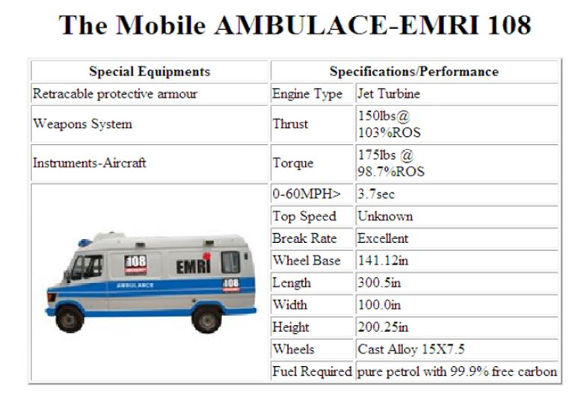

12) Using Table related tags, align the images as below output:

